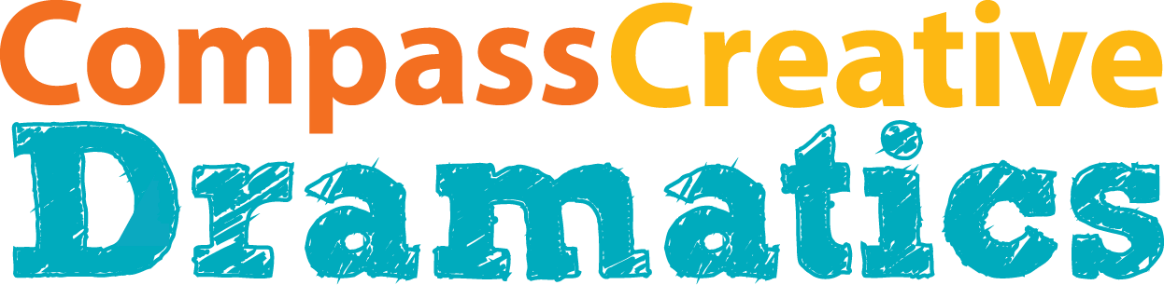 Proudly resides with [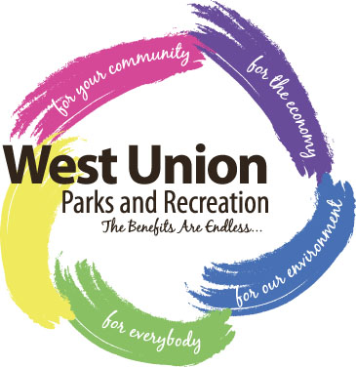
For the week of July 15-21, 2018
Registration Form

Stretch your creativity and bravery muscles as you go from audition to performance in just one week!*

Child’s name_________________________________________________________________Grade__________Gender__________

Guardian name______________________________________________________________________________________________

Address____________________________________________________________________________________________________

Phone #____________________________________ Email___________________________________________________________

Secondary Phone #_______________________________________________________________

I authorize that any photographic or videographic images of my child during the residency may be used for publicity purposes by both CCD and West Union Parks and Recreation without further notice or compensation. Questions or to opt out, please contact Kathleen Guyer. Initials: ____________

For more information about the residency please contact Kathleen Guyer at 563-380-8496 or wuparkandrec@gmail.com.

Participation fee for this program is $20 and may be paid by cash/check West Union Parks and Recreation by July 11, 2018.
This program includes care and theatrical instruction M-F from 9:00 a.m. to 12:15 p.m. by two professional actor/educators, a role in the selected play, and an opportunity to perform for a public audience. Tickets for the performances will be $5 for adults, $3 for students. Ages 5 and under are free. Tickets will be available for purchase at the door.
*Because of the very collaborative nature of the program students must be present for all rehearsals and performances to be allowed to participate.

Proudly resides with [
For the week of July 15-21, 2018
Registration Form

Stretch your creativity and bravery muscles as you go from audition to performance in just one week!*

Child’s name_________________________________________________________________Grade__________Gender__________

Guardian name______________________________________________________________________________________________

Address____________________________________________________________________________________________________

Phone #____________________________________ Email___________________________________________________________

Secondary Phone Number_______________________________________________________________

I authorize that any photographic or videographic images of my child during the residency may be used for publicity purposes by both CCD and West Union Parks and Recreation without further notice or compensation. Questions or to opt out, please contact Kathleen Guyer. Initials: ____________

For more information about the residency please contact Kathleen Guyer at 563-380-8496 or wuparkandrec@gmail.com.

Participation fee for this program is $20 and may be paid by cash/check West Union Parks and Recreation by July 11, 2018.
This program includes care and theatrical instruction M-F from 9:00 a.m. to 12:15 p.m. by two professional actor/educators, a role in the selected play, and an opportunity to perform for a public audience. Tickets for the performances will be $5 for adults, $3 for students. Ages 5 and under are free. Tickets will be available for purchase at the door.
*Because of the very collaborative nature of the program students must be present for all rehearsals and performances to be allowed to participate

